1. Ng new nameof the application

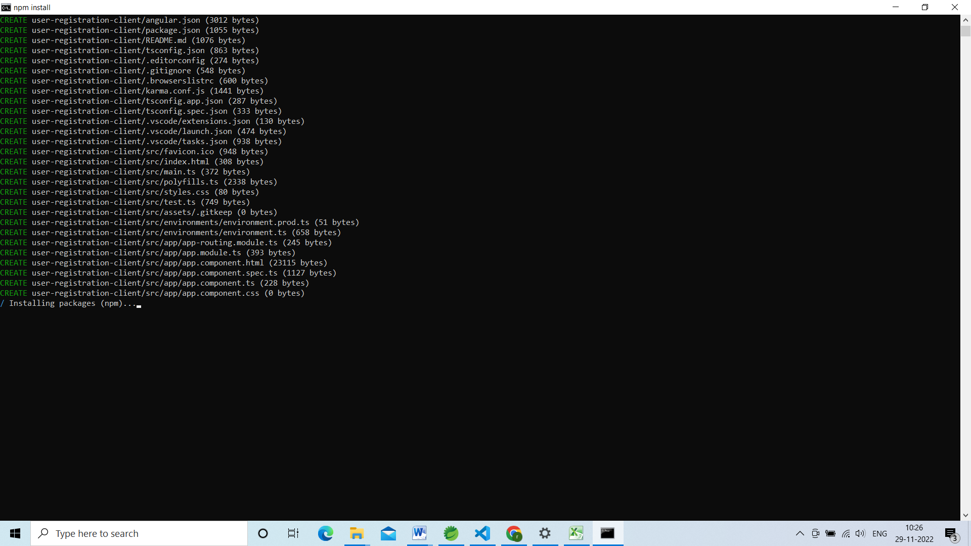

Ng g c registration

Ng g c search-delete

Ng g s user-registration

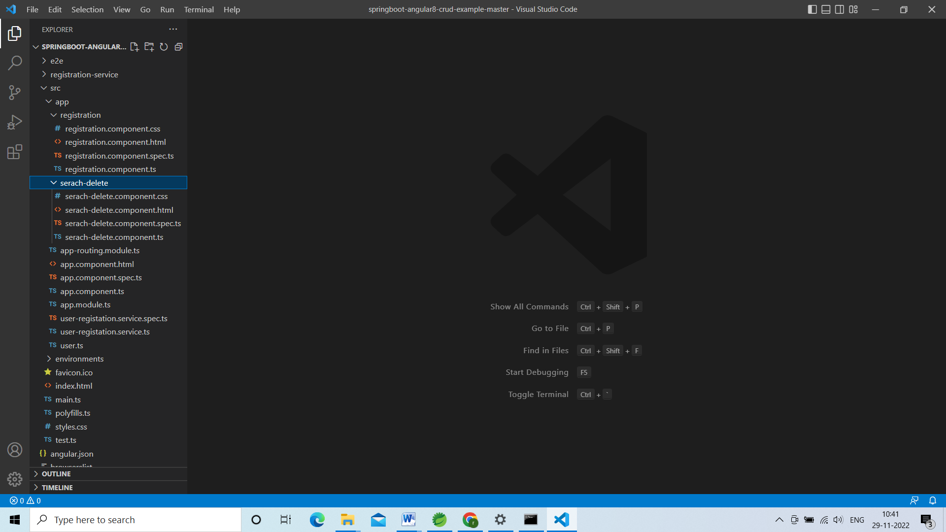

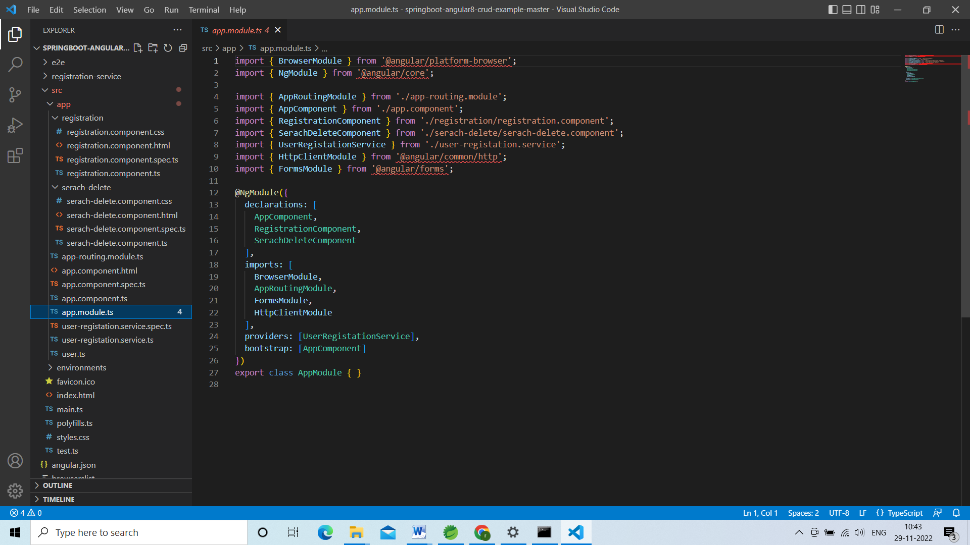

Here we have to register services classes and import httpclient module and also import the formmodule

Then go to our component registration component

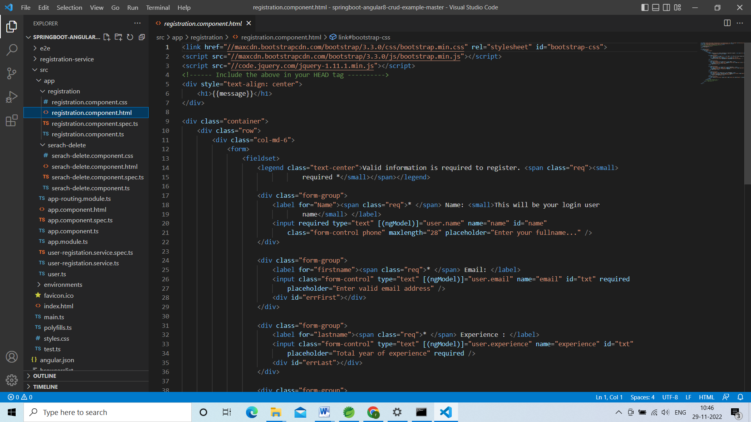

Ngmodel will be used to bind the values and we have to create one user.ts which will act as a model class

Ng model will be used to bind the values from html and add to model class called user.ts.

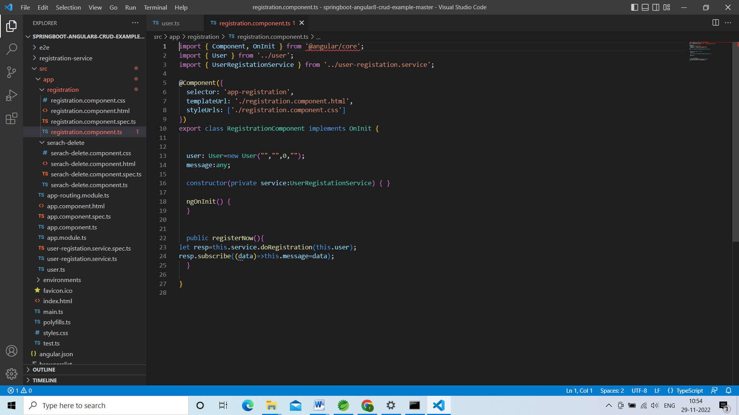

Go to usercomponent.ts here we can initialize the user object.

Go to usereregistration-service

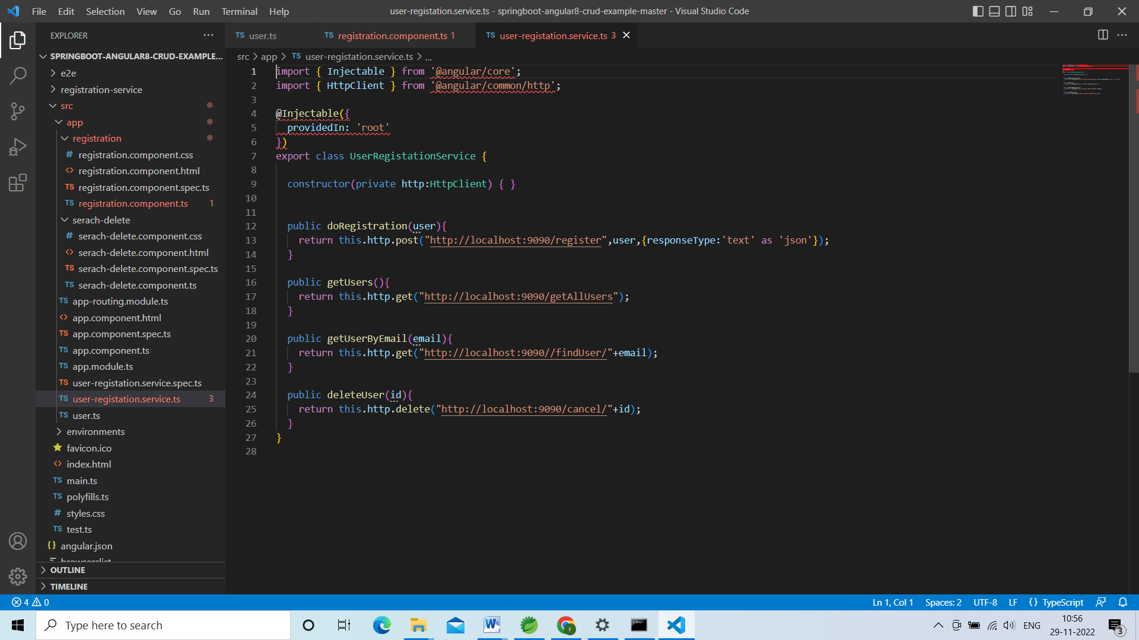

Declare the calls for restfull controller

Then we have to register this service classand methods in registration-comonent.ts file

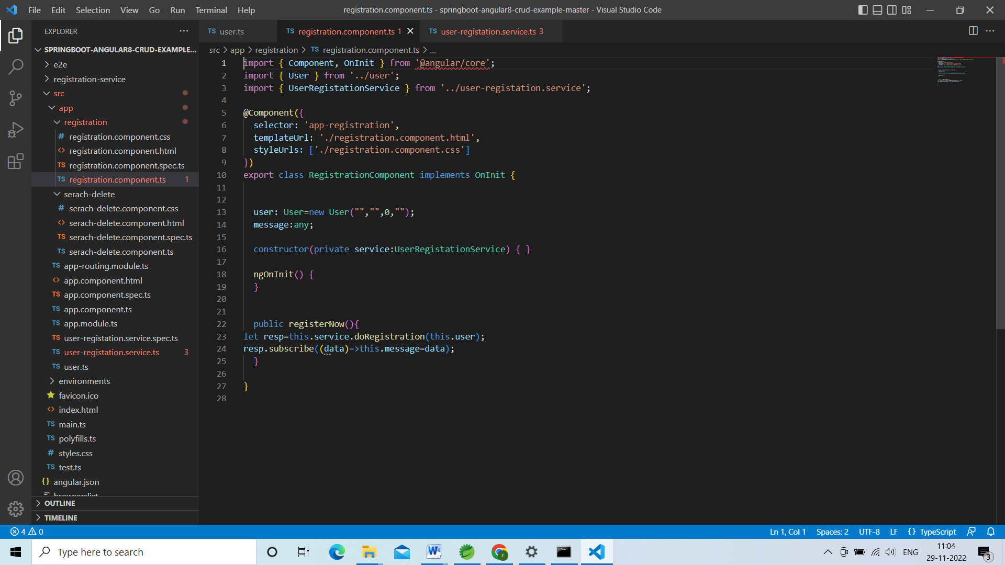

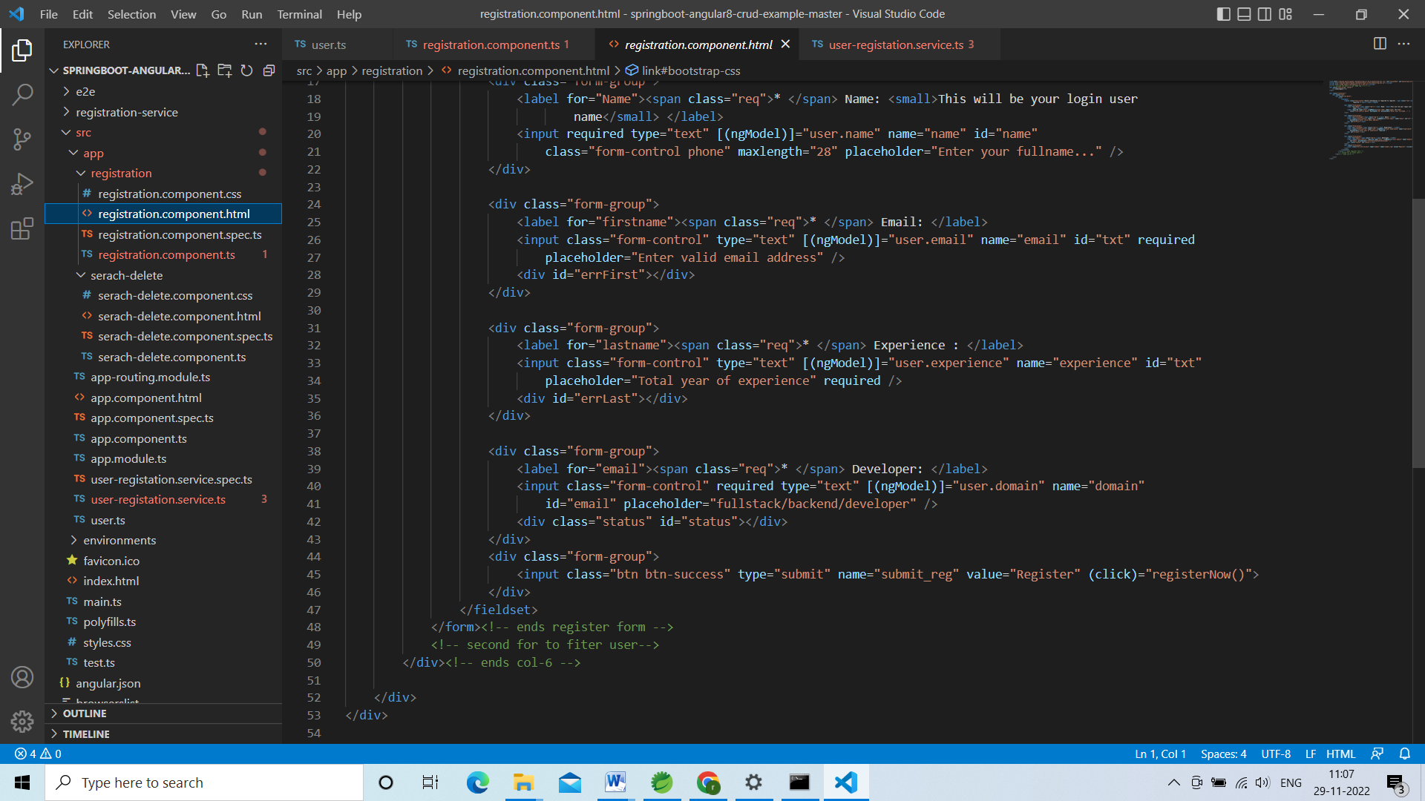

Here on click on submit button it has to go to registerNow() in registration-comonent.ts file

Whatever response we are getting we have to display in the message.

In app-routing-module we have to mention the modules for which we have to route

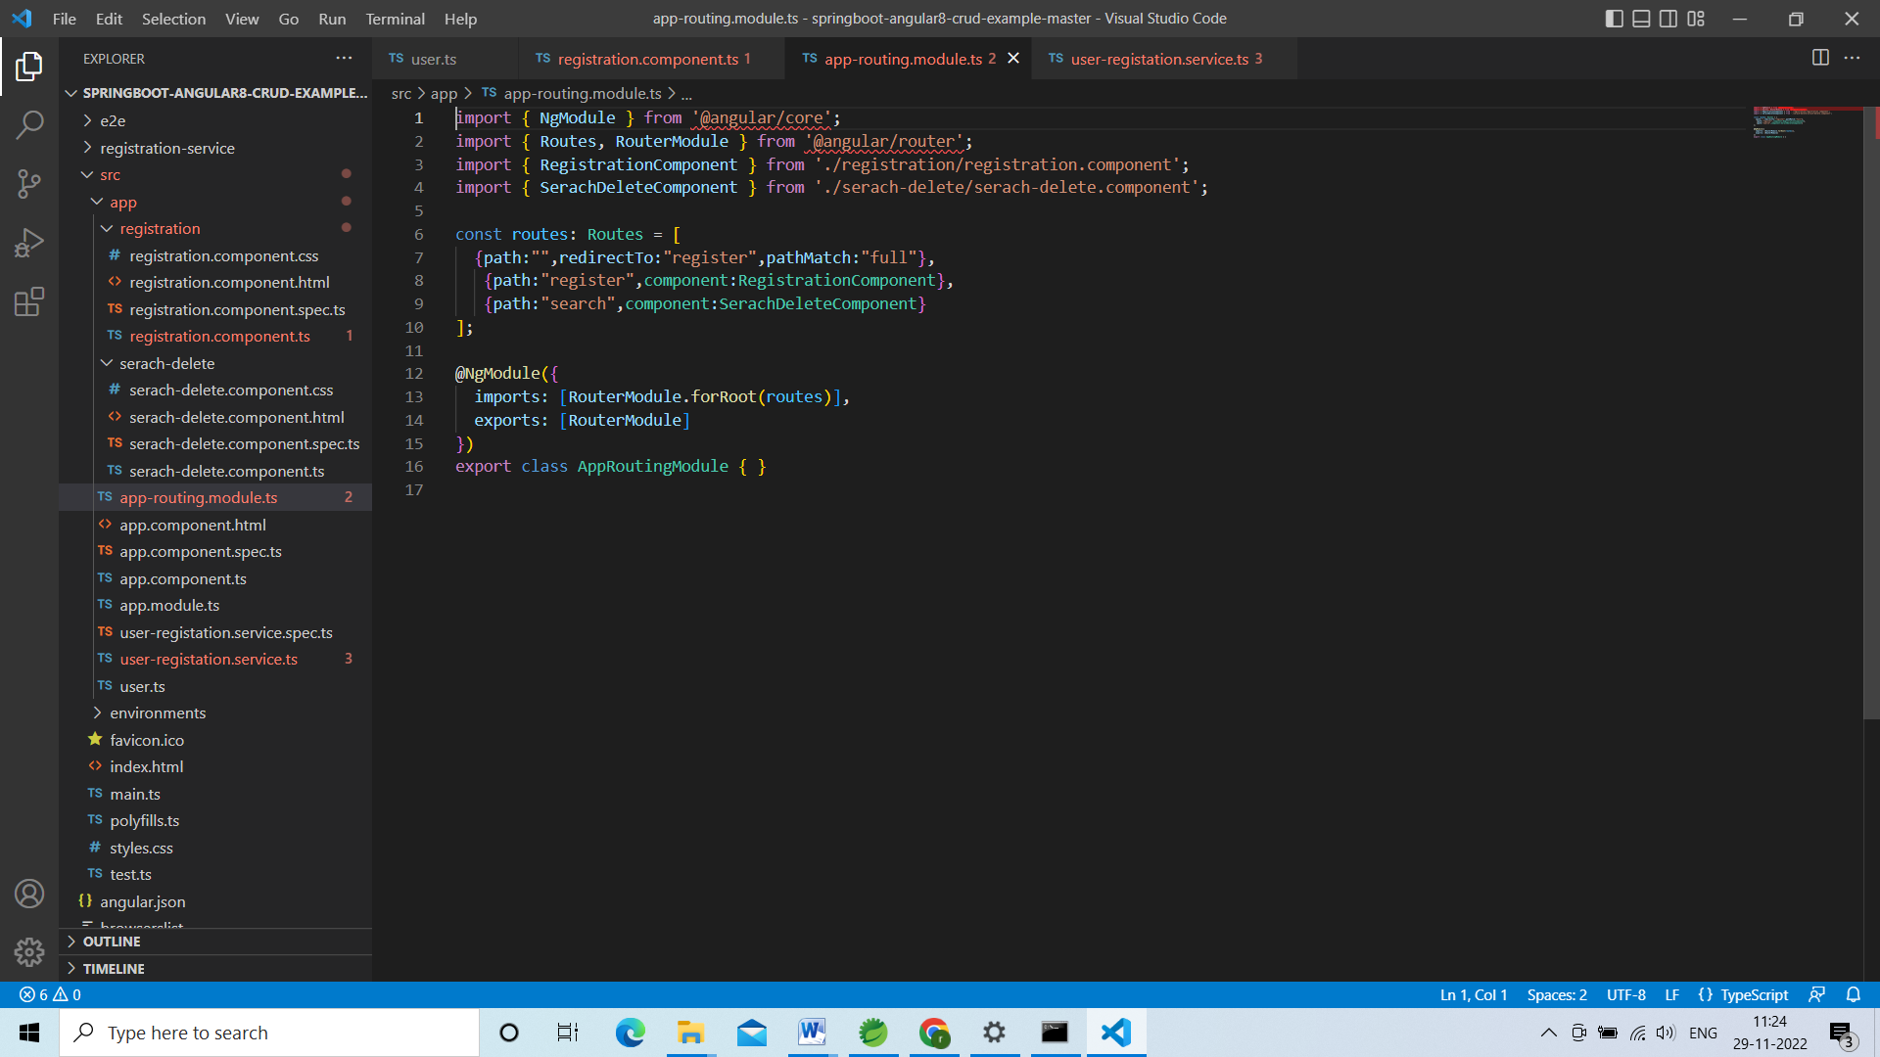

If user don’t give any thing redirect to the registration

Go to app.component.html

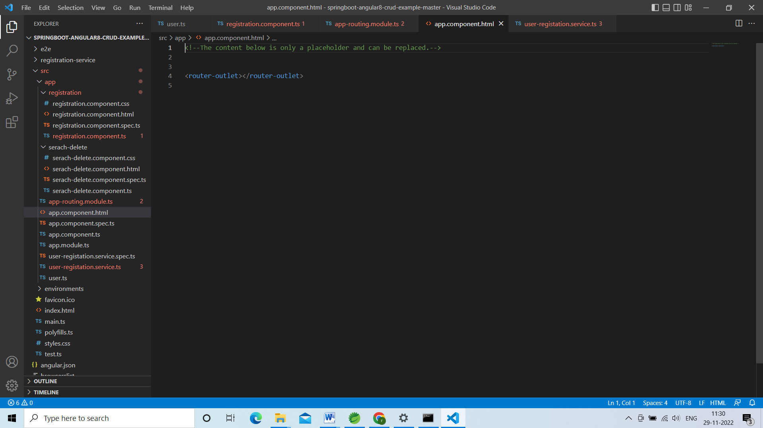

Go to terminal and check ng serve –open

In service class declare the all methods for search and delete

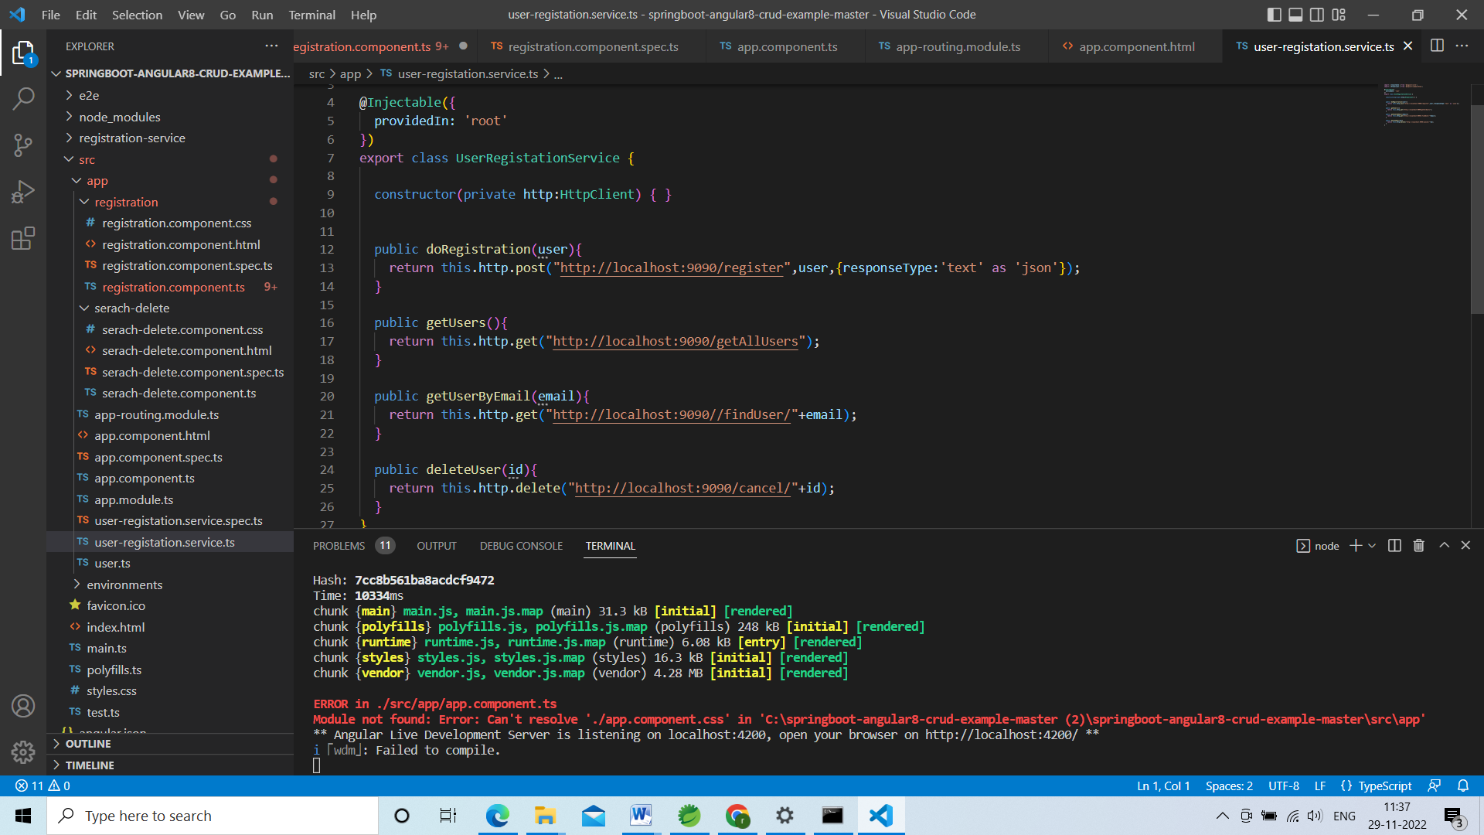

Go to sercah-delete.component.ts and initialize service and methods

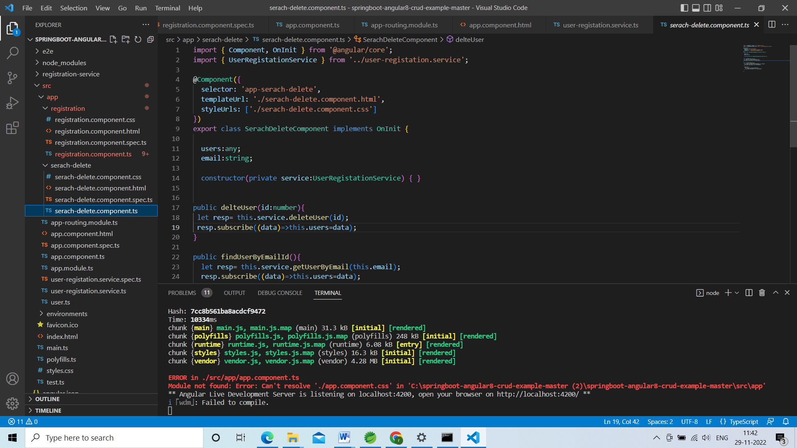

All the list of users will be in users object

Go to search-delete.component.html

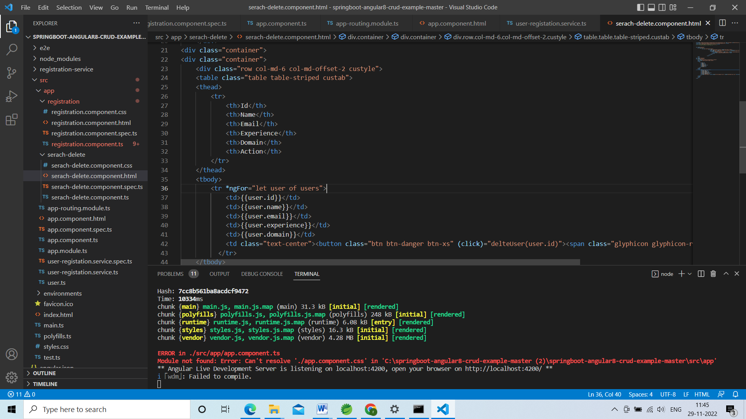

Go to serach-delete.component.ts

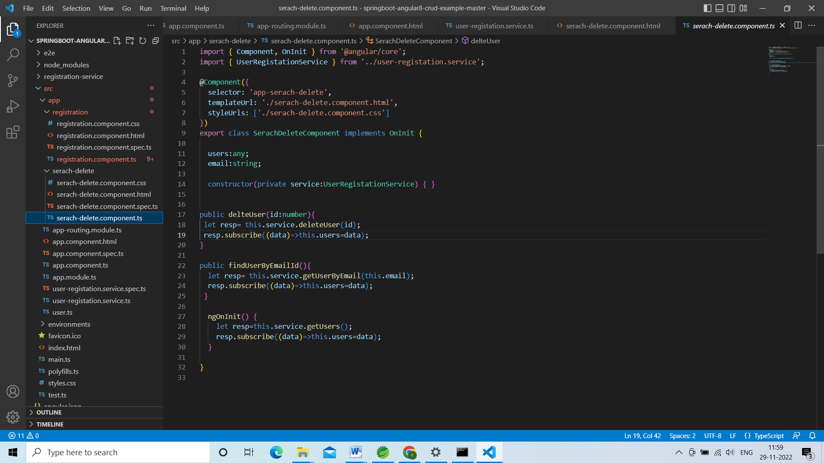

This email id we will get from the html.